TITLE OF THE ARTICLE [ARIAL 14, BOLD, CAPITAL, CENTERED]

FirstName LastName1 [ORCID], FirstName LastName2 [ORCID] … [Arial, 12-point, bold, centered]

1Affiliation, Country, email address [11-point, italics, centered]

2Affiliation, Country, email address [11-point, italics, centered]

Abstract [Arial, 12-point, bold, centred]

This template will assist you in formatting your paper. Please, insert the text keeping the format and styles. The parts of the paper (title, abstract, keywords, sections, text, etc.) are already defined on the style sheet. An approximately 200-word abstract in two languages (in English and in the original language of the article) must be submitted at the beginning of the article. The abstract should summarize the content of the article and include the following: research aims, methodology, and main findings of the study. Up to five keywords should be included. Please do not include your personal data in this file, namely the first and last name of each author, nor should you indicate affiliation, country and email address. These data will be added after the article is accepted for publication. In Microsoft Word, you should also remove the author identification in the file properties (see "File" menu): File > Save As > Tools (or Options on Mac) > Security > Remove personal information from file on save > Save.

Keywords: first, second, third, fourth, fifth. [Arial, 10-point, justified alignment].

# INTRODUCTION AND SECTIONS TITLES [ARIAL, 12-POINT, BOLD, CAPITAL AND LEFT ALIGNMENT]

All text must be in one column and use Arial font, including figures and tables, with single spacing of 10 points between lines. [Arial, 10 points, normal alignment, justified]

Define abbreviations and acronyms the first time they are used in the text, even after they are defined in the abstract. Do not use abbreviations in the title or headings unless they are unavoidable.

Do not add any pagination anywhere in the article. Avoid using headers and footnotes.

# SECTION TITLE

Text included in sections or subsections must start on a line after the title of the section or subsection. Do not use tabs.

## Subsection [Arial, 12-point, bold, left-aligned and capitalized on first letter]

Do not manually number sections and subsections; the model will do this automatically. Use as many sections/subsections as needed.

Tables and figures must be centered and numbered independently, in the sequence in which they appear in the text. To mention them in the text, use “Figure 1”, even at the beginning of a sentence. Do not use abbreviations. Figures and tables must be accompanied by a legend. Both figures and table legends must appear above the tables. Use the following examples:

Table 1

Table’s title

|  |  |  |
| --- | --- | --- |
| Title 1 | Title 2 | Title 3 |
| One | 1 | A |
| Two | 2 | B |
| Three | 3 | C |

*Note. Notes explain, qualify, or provide information about the table as a whole. Put explanations of abbreviations, symbols, among others, here.*

Figure 1

Figure’s title

*Note. It may include explanations to complement or clarify information regarding the image. Indicate whether it is a reprinted or adapted image.*

Video 1

Video’s title

[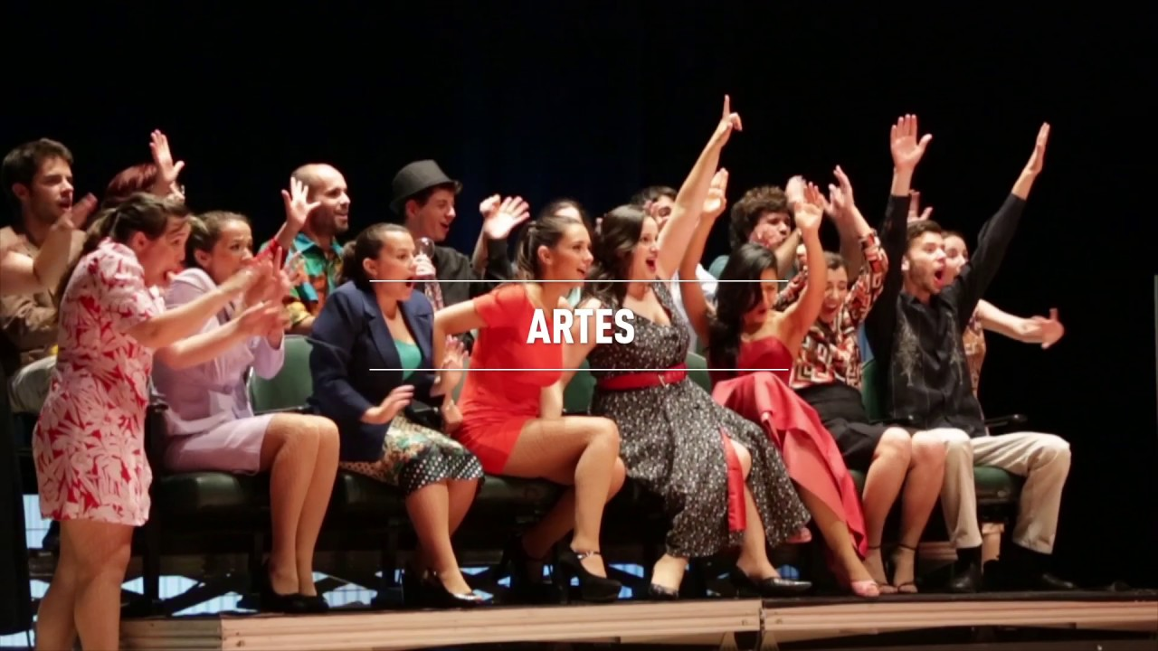](https://www.youtube.com/watch?v=pIRTbN5YiIQ)

*Note. It may include explanations to complement or clarify information regarding the video.*

# CONCLUSIONS / FINAL CONSIDERATIONS

In this section you should include a summary of your article, possible future paths for research in the same field, as well as its main limitations.

ACKNOWLEDGMENTS [ARIAL, 12-POINT, BOLD, LEFT ALIGNMENT]

It is possible to insert, optionally, a text to thank other contributors, assistance or financial support.

REFERENCES [ARIAL, 12-POINT, BOLD, LEFT ALIGN]

The list of references should be provided at the end of the work. Please use APA (7th Edition) for citations and references (https://apastyle.apa.org/style-grammar-guidelines). The following bibliography provides a sample reference list with entries for journal articles, chapters, books, proceedings, as well as online resources.

American Psychological Association. (n.d.). Just-world hypothesis. In *APA dictionary of psychology*. Retrieved January 18, 2020, from https://dictionary.apa.org/just-world-hypothesis

Aron, L., Botella, M., & Lubart, T. (2019). Culinary arts: Talent and their development. In R. F. Subotnik, P. Olszewski-Kubilius, & F. C. Worrell (Eds.), *The psychology of high performance: Developing human potential into domain-specific talent* (pp. 345–359). American Psychological Association. https://doi.org/10.1037/0000120-016

Baral, P., Larsen, M., & Archer, M. (2019*). Does money grow on trees? Restoration financing in Southeast Asia*. Atlantic Council. <https://www.atlanticcouncil.org/in-depth-research-reports/report/does-money-grow-on-trees-restoring-financing-in-southeast-asia/>

Carey, B. (2019, March 22). Can we get better at forgetting? *The New York Times.* https://www.nytimes.com/2019/03/22/health/memory-forgetting-psychology.html

Crimi, C. (2019). *Weird little robots* (C. Luyken, Illus.). Candlewick Press.

Department for Business Innovation & Skills. (2016). *Success as a knowledge economy: Teaching excellent, social mobility and student choice* [White paper]. Crown. <https://www.gov.uk/government/uploads/system/uploads/attachment_data/file/523396/bis-16-265-success-as-a-knowledge-economy.pdf>

Dillard, J. P. (2020). Currents in the study of persuasion. In M. B. Oliver, A. A. Raney, & J. Bryant (Eds.), *Media effects: Advances in theory and research* (4th ed., pp. 115–129). Routledge.

Grady, J. S., Her, M., Moreno, G., Perez, C., & Yelinek, J. (2019). Emotions in storybooks: A comparison of storybooks that represent ethnic and racial groups in the United States. *Psychology of Popular Media Culture, 8*(3), 207–217. <https://doi.org/10.1037/ppm0000185>

Jackson, L. M. (2019). *The psychology of prejudice: From attitudes to social action* (2nd ed.). American Psychological Association. <https://doi.org/10.1037/0000168-000>

Lyons, D. (2009, June 15). Don’t ‘iTune’ us: It’s geeks versus writers. Guess who’s winning. *Newsweek, 153*(24), 27.

Merriam-Webster. (n.d.). Semantics. In *Merriam-Webster.com dictionary*. Retrieved January 4, 2020, from <https://www.merriam-webster.com/dictionary/semantics>

Pitman, G. E. (2016). *This day in June* (K. Litten, Illus.). Magination Press.

Slater, D. (2017). *The antlered ship* (T. Fan & E. Fan, Illus.). Beach Lane Books.

Stobbe, M. (2020, January 8). Cancer death rate in U.S. sees largest one-year drop ever. *Chicago Tribune.*

Stuster, J., Adolf, J., Byrne, V., & Greene, M. (2018). *Human exploration of Mars: Preliminary lists of crew tasks* (Report No. NASA/CR-2018-220043). National Aeronautics and Space Administration. <https://ntrs.nasa.gov/archive/nasa/casi.ntrs.nasa.gov/20190001401.pdf>

Thestrup, K. (2010). To transform, to communicate, to play—The experimenting community in action. In E. Hygum & P. M. Pedersen (Eds.), *Early childhood education: Values and practices in Denmark*. Hans Reitzels Forlag. <https://earlychildhoodeducation.digi.hansreitzel.dk/?id=192>